Web dev Project 1
Matthew O’Connell Cantillon
20116512
Computer Forencis and Cybersecurity
W1
Web dev Project 1 1

Brief Plan

- 3 webpages
- Personal, interests (repair section) and an introduction page, maybe a game page (if i dont leave this too late)
- Include previous college courses
- My interest in repairing with images
- Dog photos for free marks (not bribery)

Wireframe
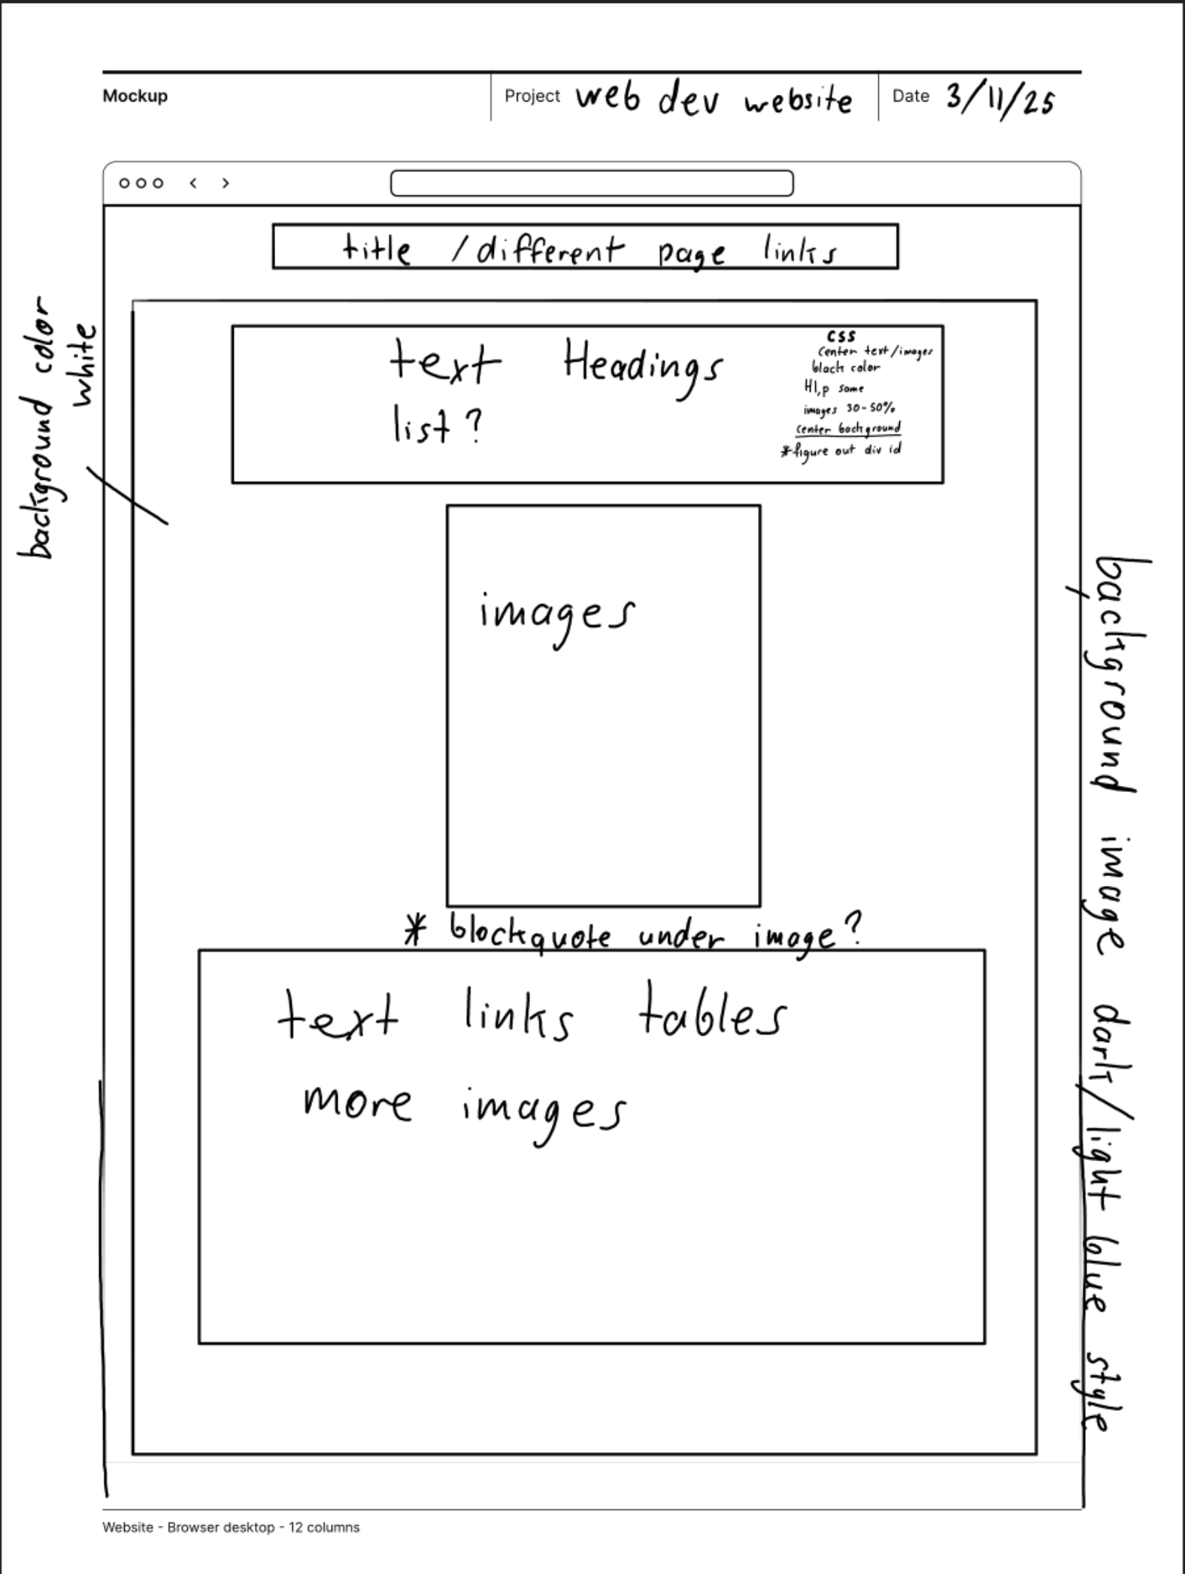

Visual Design

Colour idea
Depending on which background image i pick, the rest of the colours will include either a dark purple or blue for borders and headers and white for the center text, and maybe borders around each image and text (or around the page, depends which looks nicer)

Types of Images
Dog photos, repair photos and one of me, landscape would be cleaner and easier to use in tables.
Convert them from heic to jpg to avoid any compatibility issues and see how they look with borders around them

Layout of pages
Keep everyting center, so the edges and maybe the bottom can show parts of the background image
Plus it makes text look cleaner and easier to read (in my experience)
Nav bar uptop with highlight hover, maybe white bold text. Might include a differnet color appears when you click on that link

